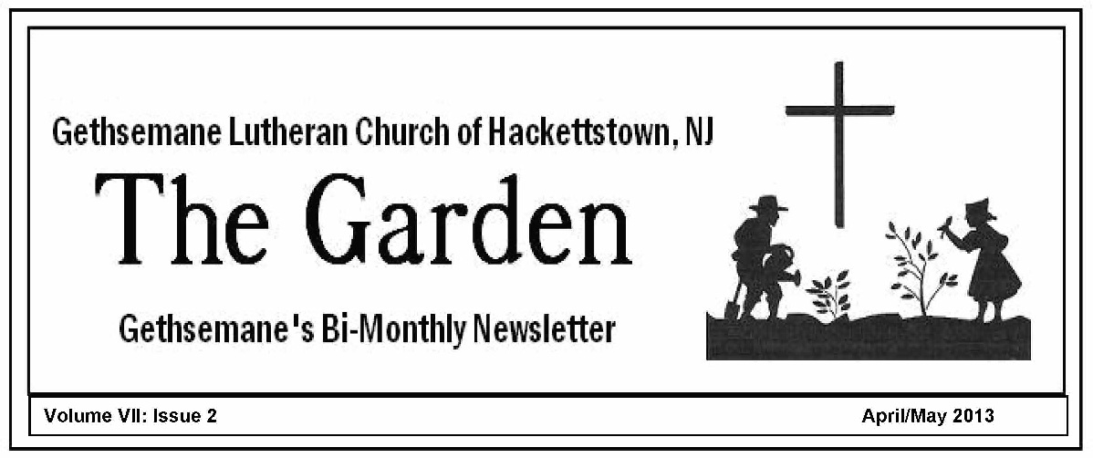
Volume VII: Issue 1 February/March 2013
                                                                                                                                                 
Volume VII: Issue 2 April/May 2013

HOLY WEEK/EASTER AT GETHSEMANE

Sunday, Mar.24: Palm/Passion Sunday:
10:30am
Holy Communion, including Reading of the Passion Narrative from St.Luke and Blessing of the Palm Crosses.

Thursday, Mar.28: Maundy Thursday Worship,
7 pm.
Holy Communion, with Footwashing and Stripping of the Altar.

Friday, Mar.29: Good Friday Worship
7pm.
Choir Cantata: "Calvary's Mountain"

Sunday, Mar.31: Easter Sunday--
6:30am Sunrise Communion, including Lighting of the Paschal Candle;
7:30am Easter Breakfast;
10:30am Easter Festival Service of the Resurrection

About Our Services for Holy Week/Easter

St.Augustine called Holy Week the Great Week because of all the great things that were accomplished during these days.

*Palm/Passion Sunday: The term "passion" here is from a Latin word meaning suffering. Palm/Passion Sunday focuses especially on our Lord's suffering, as we read and hear the narrative from St.Luke, read by the congregation and readers. Also, palm crosses made by fellow Christians in mud villages in Tanzania will be handed out.These are by custom taken home and placed behind crosses or religious pictures.

*Maundy Thursday: "Maundy" comes from a Latin term for "commandment", referring to Jesus' new commandment to "love one another as I have loved you." So much happened on the Thursday of Holy Week: the Last Supper, the Footwashing, Jesus praying in the Garden and His arrest. In our worship this year, all six of our confirmation students will have their feet washed by Pastor. The service will conclude with the Stripping of the Altar, while Psalm 22 is read (the Psalm that Jesus spoke while on the cross). The Stripping involves removal of all the candles, the paraments and altar cloth, missal stand, and Eucharistic vessels, symbolizing Christ being stripped of his power and glory and being handed over to his captors.

*Good Friday: Good Friday is "good" because of our Lord's payment for our sins to accomplish our salvation, though the actual events were anything but "good" in the traditional sense. Normally, this is a service of austere reflection and meditation. This year, our Chancel Choir will help us meditate as they lead us in a cantata, "Calvary's Mountain", including readings from St.John's Gospel and hymns like "What Wondrous Love is This" and "Were You There". The service concludes, as in previous years, with the Extinguishing of the Light, as the Christ candle is carried out of the darkened church in silence.

*Easter Sunday: This is the Festival of the Resurrection of our Lord Jesus Christ, the oldest and holiest of Christian festivals, the climax of the liturgical year, and the holy day to which all holy days point.
At our 6:30am service, we will have the lighting of the Paschal candle, which symbolizes the presence of the Risen Christ, and which will stand by the altar for the 50 days of Easter. The lighting, usually done on the Vigil of Easter, will be followed by a procession into the darkened nave.
The 10:30am service is a full celebration of Holy Communion, and this year we are pleased to have trumpet accompaniment of our hymns.

CHURCH PICNIC IS COMING ON JUNE 9
Yes, spring just started, but summer is also around the corner.....so we will again gather for our Church Picnic on Sunday, June 9 on the church grounds following our 10:30am worship.

This year is an old-fashioned "barbeque"....so we're looking for a few volunteers who like grilling, especially chicken, hot dogs, hamburgers, and whatelse. Watch for signups to donate food in May.

If you're able to volunteer now to 1) do some grilling, or 2) to help lead a few games for our children and youth, please let Pastor or Toni Torchi or Eleanor Yurkutat know.

Oh, yes: if anyone has a contact or access to a dunking booth, let us know!
NEW MEMBERS RECEIVED ON MARCH 17

On a day when we adopted St.Patrick as a honorary Lutheran, Gethsemane was blessed by the presence of more than 50 baptized new members who made a commitment to join in our Kingdom work and partnership in the Gospel here. It was the largest new member class that Pastor has been a part of, with 22 families or individuals.

Their names and addresses have been added to a newly-printed congregational directory, now available to all. But it will be up to you to add their names and faces (and stories) to your personal relationships. The Church Council will be hosting a special New Member Luncheon in the Fellowship Hall on Sunday, April 28th after our worship service. Of note: one of our new members is Don Pulver, who has served as our sexton for 29 years, and who will be baptized on April 6!"

SAVE THE DATE! SATURDAY, APRIL 13TH
EVERYONE, and we mean EVERYONE, is invited to our VISION DAY at Gethsemane. After all the work leading up to the consultation and the resulting "prescriptions", this is the main item on our future agenda at this moment in our history. PLEASE SAVE THE SATURDAY, APRIL 13, 9AM TILL 3PM, for us to gather and work at setting a unified direction for our future and the Kingdom work God has in mind of us.

Our lead consultant from last October, the Rev.David Born, will return and help us identify at least five issues or needs that will shape our vision. Presumably, these will include our "stance" toward our neighbors, our community and the "lost" around us. He will be utitilizing also the information we gain through our neighborhood surveys.

CONFIRMATION SUNDAY IS MAY 5
Please join us on Sunday, May 5, as three confirmands are confirmed in the Christian faith, promising their loyalty to Christ. We rejoice with the families of Stephanie Burr, daughter of Don; Jeremy Diehl, son of David and Carol; and Steven Hill, son of Ed and Sue.

VOTERS' MEETING IS SUNDAY, MAY 19
Our Spring Voters' meeting is scheduled for Sunday, May 19, immediately following our worship service. The agenda includes election of Council members for the 2013-14 term, and the adoption of the Bylaw changes proposed one year ago. All members invited.
SENIORS' LUNCHEON UPDATE
Anyone who's a senior (you decide the age limit) is invited to our monthly seniors' luncheon, usually the fourth Wednesday of each month at 12:30pm in the Fellowship Hall. We just had a representative from Calico Flowers give us a floral demonstration at our Mar.20 luncheon. On schedule for the next three months:
*April 24: Presentation on Medigap
*May 22: Our version of the Antique Road Show, starring
Ed Petrie
*June 26: Comfort Dogs (we hope to have a
demonstration).
Contact Eleanor Yurkutat, Jan Long, or Pastor if you have any questions.


SAVE THE DATE FOR VBS 2013

The dates have been set for VBS this summer. They are JULY 29 – AUG 2, 9:00 – 11:45 am, so mark your calendars. This year we’re bringing a global fair to the kids with the theme “EVERYWHERE FUN FAIR: WHERE GOD’S WORLD COMES TOGETHER!”
Children will learn to share God’s love with their neighbors by focusing on the themes that: Neighbors are friendly! Neighbors are giving! Neighbors are bold! Neighbors are forgiving! And Neighbors are welcoming!
There will be Bible stories, crafts, music, recreation, snacks and of course lots of fun. Children age 4 through 4th grade may participate as students and 5th graders and older (and this includes adults) may be helpers.
Contact the church office (908-852-2156, gethsemanehtown@verizon.net) for registration and Susie Herzberg (908-979-0024, susieherzberg@gmail.com) to be a helper.
Invite a neighbor and join us in July!!!

TWO MORE OPPORTUNITES TO PRAYERWALK OR HELP WITH A NEIGHBORHOOD SURVEY:

*A Prayerwalk is slated for Sat. April 6, 9:00am, as we prepare for our Vision Day on April 13.
*A Neighborhood Survey is scheduled for Sunday, April 7, right after our worship service. We especially need volunteers, as this will be the final opportunity to do surveys that are used for the Vision Day planning.
These are one-minute,3-question surveys, taken from door-to-door in several neighborhoods in our community.
UPCOMING DATES OF IMPORTANCE
Sat. Apr. 6 Prayerwalk, 9:30 am
Sun. Apr. 7 Women's Guild Bake Sale
/Neighborhood Survey
Sat. Apr. 13 VISIONING DAY here, 9 am
Sat. Apr. 20 Women’s Guild Annual Silver
Tea, 1:00 pm
Sun. Apr. 28 New Member Luncheon after Worship
Sun. May 5 Confirmation Sunday
Sun. May 19 Church Picnic/Music Appreciation
Mon. Jul. 29-Aug. 2 Vacation Bible School

Secret Prayer Pals

Easter & Spring! What a wonderful combination! As we celebrate this season, let us also remember our special friends in Christ, our Secret Prayer Pals. We pray for them daily, but we might also want to let them know we care for them with a card and/or a small gift this Easter season. Then, within a month comes Mother's day and another opportunity to show our love. And always remember your Secret Prayer Pal's birthday and anniversary (if she has one).
If you have any questions, comments or concerns, ask Marilyn Meeks.
And remember, have fun!
Save Your Labels for Bethesda011 Page 7
Many educational institutions use Campbell and Campbell divisions labels to "purchase" support items for the work that they do. For many years, LWML Societies have been sending their labels to Bethesda Lutheran Homes —residence facilities for the developmentally disabled. If you make a Green Bean Casseole (recipe below) for Easter Dinner, please remember to save your labels. Please place your Campbell labels in the blue box in the hall. A wide variety of items from these Campbell divisions are eligible for this program: Campbell’s®, Franco-American®, Pepperidge Farm®, V8® beverages, Prego® Pasta sauces, and more. Thanks for helping God’s Special Children.

Classic Green Bean Casserole

1 can (10 3/4 ounces) Campbell's® Condensed Cream of Mushroom Soup (Regular, 98% Fat Free or Healthy Request®)
1/2 cup milk
1 teaspoon soy sauce (optional)
Dash ground black pepper
4 cups cooked cut green beans
1-1/3 cups French's® French Fried Onions

1. Stir the soup, milk, soy sauce, black pepper, beans and 2/3 cup onions in a 1 1/2-quart casserole.
2. Bake at 350°F. for 25 minutes or until the bean mixture is hot and bubbling. Stir the bean mixture.
Sprinkle with the remaining onions.
3. Bake for 5 minutes or until the onions are golden brown.


THANK YOU
Thank you to everyone who supported the Easter baskets for LSM/NJ. With all the donations we were able to make 24 baskets. These baskets will go to the many agencies that fall under Lutheran Social Ministries care. If you wish to know more about LSM/NJ and the many programs and services they offer, go to lsmnj.org.

BAKE SALE
Cakes, Pies, and all types of goodies.

April 7, 12:00 to 1:00
(right after worship service)

All proceeds will go to help defray the cost of our ladies who will be traveling to the national LWML convention in Pittsburgh. These ladies will be good will ambassadors from Gethsemane. They will be greeting and helping the 3000-4000 women who will converge on Pittsburgh from across our nation. So please come out and support our women.
Would you like to be part of this group of men and women heading for Pittsburgh at the end of June? There are many areas of service. We would love to tell you more.
Contact Ginger Starrett or Marilyn Meeks for more information. Also see the Woman’s Guild bulletin board for an overview.
Silver Tea

Hosted by the Woman’s Guild
Saturday, April 20
1:00 – 3:30 pm

20 varieties of Tea
Scones
Soup
Tea sandwiches
&
Dessert

The tea is open to all members of Gethsemane. But we would love for you to bring your mother or your child or a new friend who is not a member of Gethsemane. There will be a game and a special guest. Come out and enjoy an afternoon of fellowship and fun.
Sign up sheet on the Women’s Guild board. Questions? please call Ginger Starrett @ 908-500-7337. or
Email starrettfam@comcast.net

Gethsemane Lutheran Church
409 East Baldwin Street
Hackettstown, NJ 07840

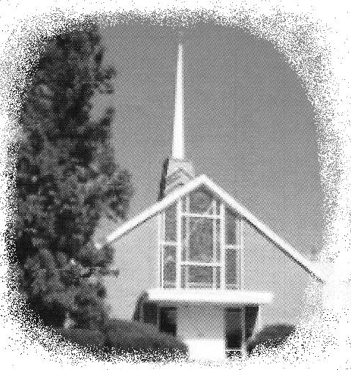

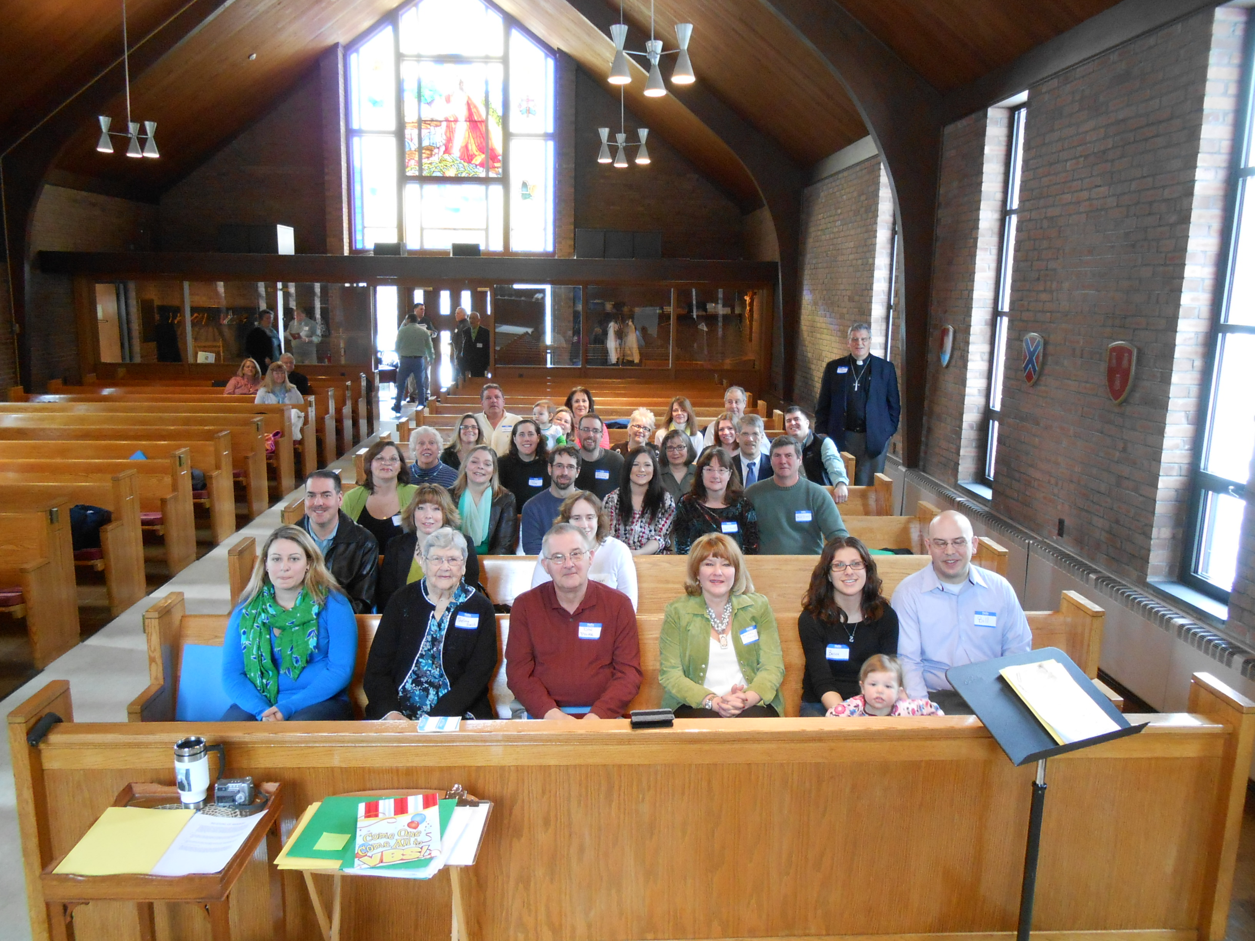

OUR NEWEST MEMBERS AT ORIENTATION (Minus a few children!) Received March 17, 2013

